Hello World RESTful Web Service
Scenario: Write a REST service in the Spring Learn application that returns the text "Hello World!!" using the Spring Web Framework. The service exposes a GET endpoint at /hello, implemented in the HelloController class, and logs a start and end message inside the sayHello() method.

What Was Done
• Created a new Spring Boot project named spring-learn using Spring Initializr with the Spring Web dependency.
• Set the application to run on port 8083 by adding server.port=8083 in application.properties.
• Created the controller package and added the HelloController class inside it.
• Implemented the sayHello() method mapped to GET /hello, returning the hard-coded string "Hello World!!".
• Added SLF4J logger statements at the start and end of the sayHello() method as required.
• Ran the Spring Boot application and confirmed Tomcat started successfully on port 8083.
• Verified the endpoint in Chrome browser and checked the response headers using Chrome DevTools Network tab.
• Verified the endpoint in Postman and checked the response headers using the Headers tab.

Result
The REST service was created and tested successfully. Hitting http://localhost:8083/hello in both Chrome and Postman returned the expected response "Hello World!!" with HTTP status 200 OK. The application console confirmed the start and end log messages were printed on every request.

Project Structure and Main Application Class
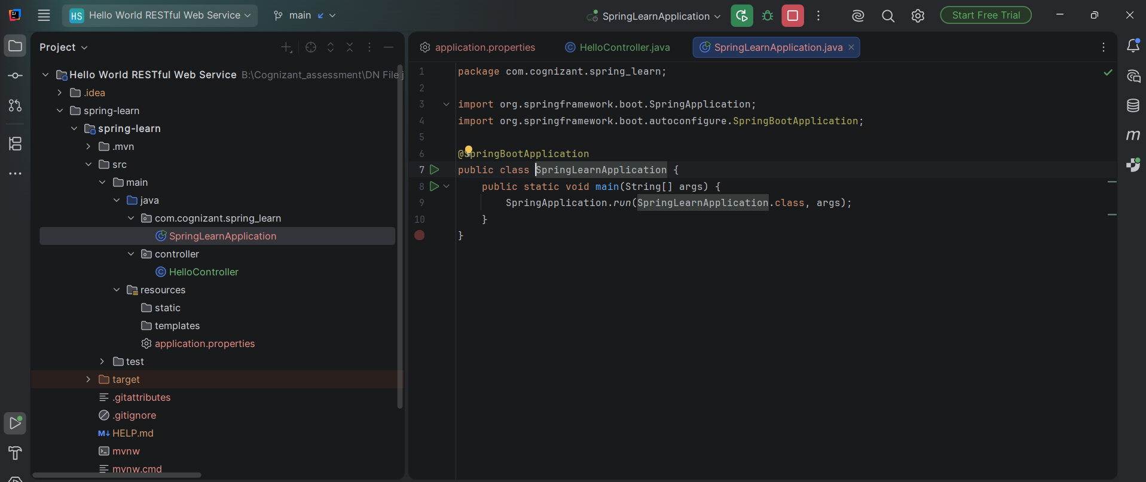
Figure 1: Project structure showing controller package with HelloController, and the main SpringLearnApplication class.

HelloController Implementation
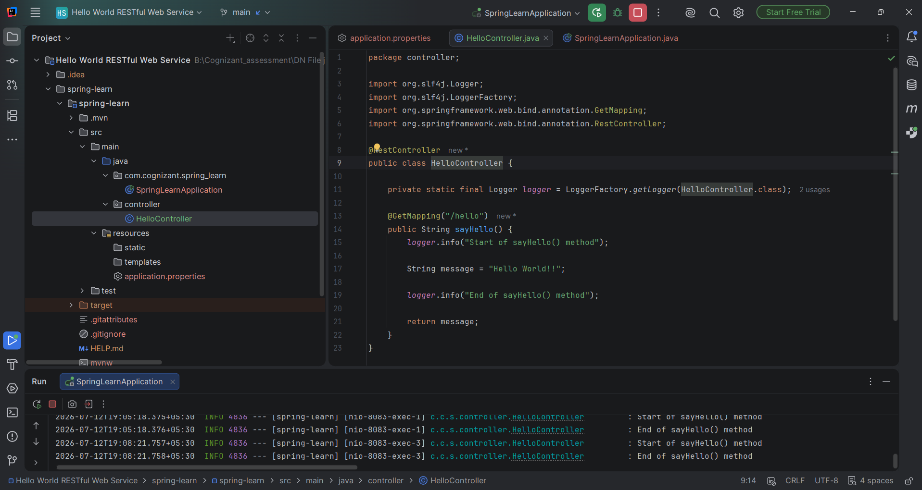
Figure 2: HelloController.java with sayHello() method, GET mapping for /hello, and start/end log statements.

application.properties Configuration
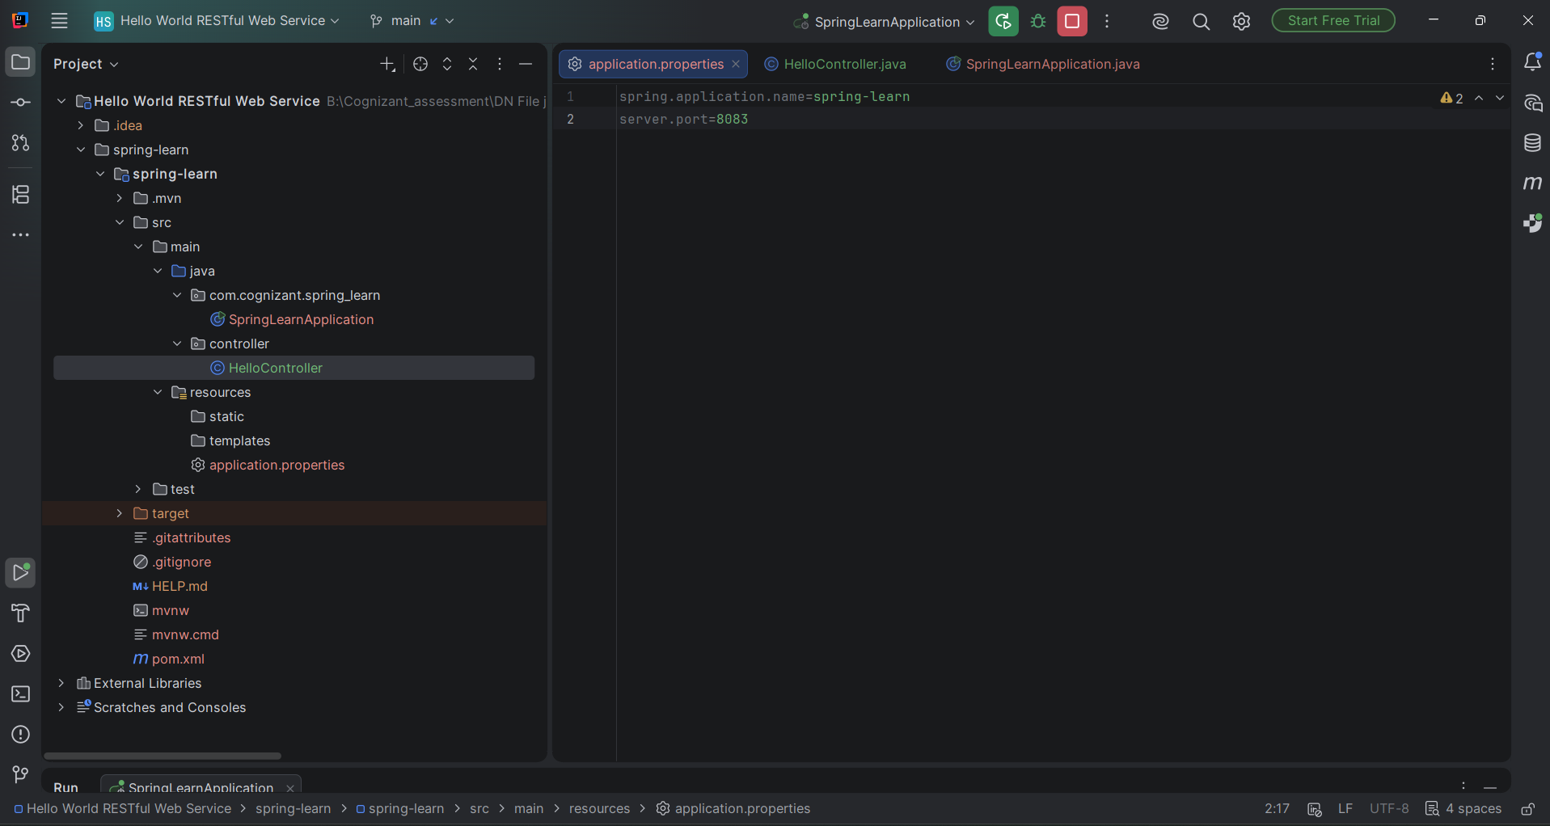
Figure 3: application.properties configured with server.port=8083.

Application Console Logs
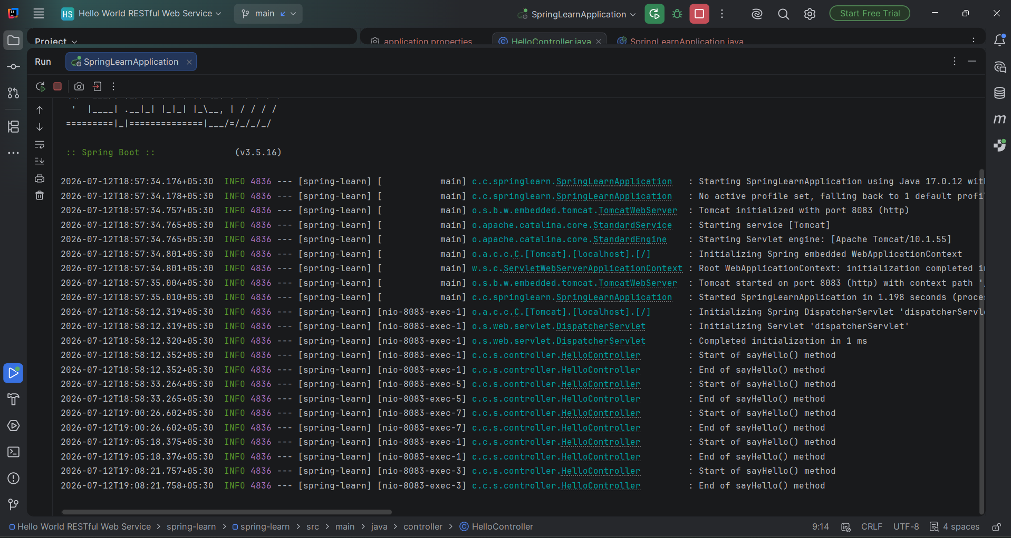
Figure 4: Console output showing Tomcat started on port 8083 and repeated Start/End of sayHello() log entries for each request.

Testing in Chrome Browser
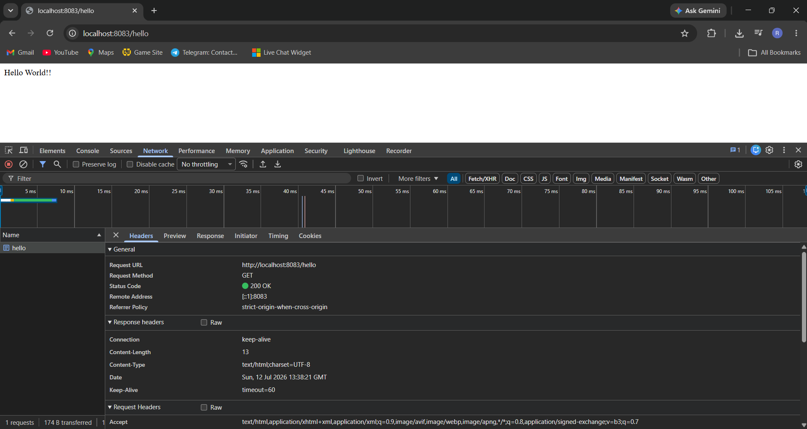
Figure 5: Chrome browser displaying "Hello World!!" and DevTools Network tab showing the response headers (Content-Type, Content-Length, Date, Keep-Alive, Connection).

Testing in Postman - Response Body
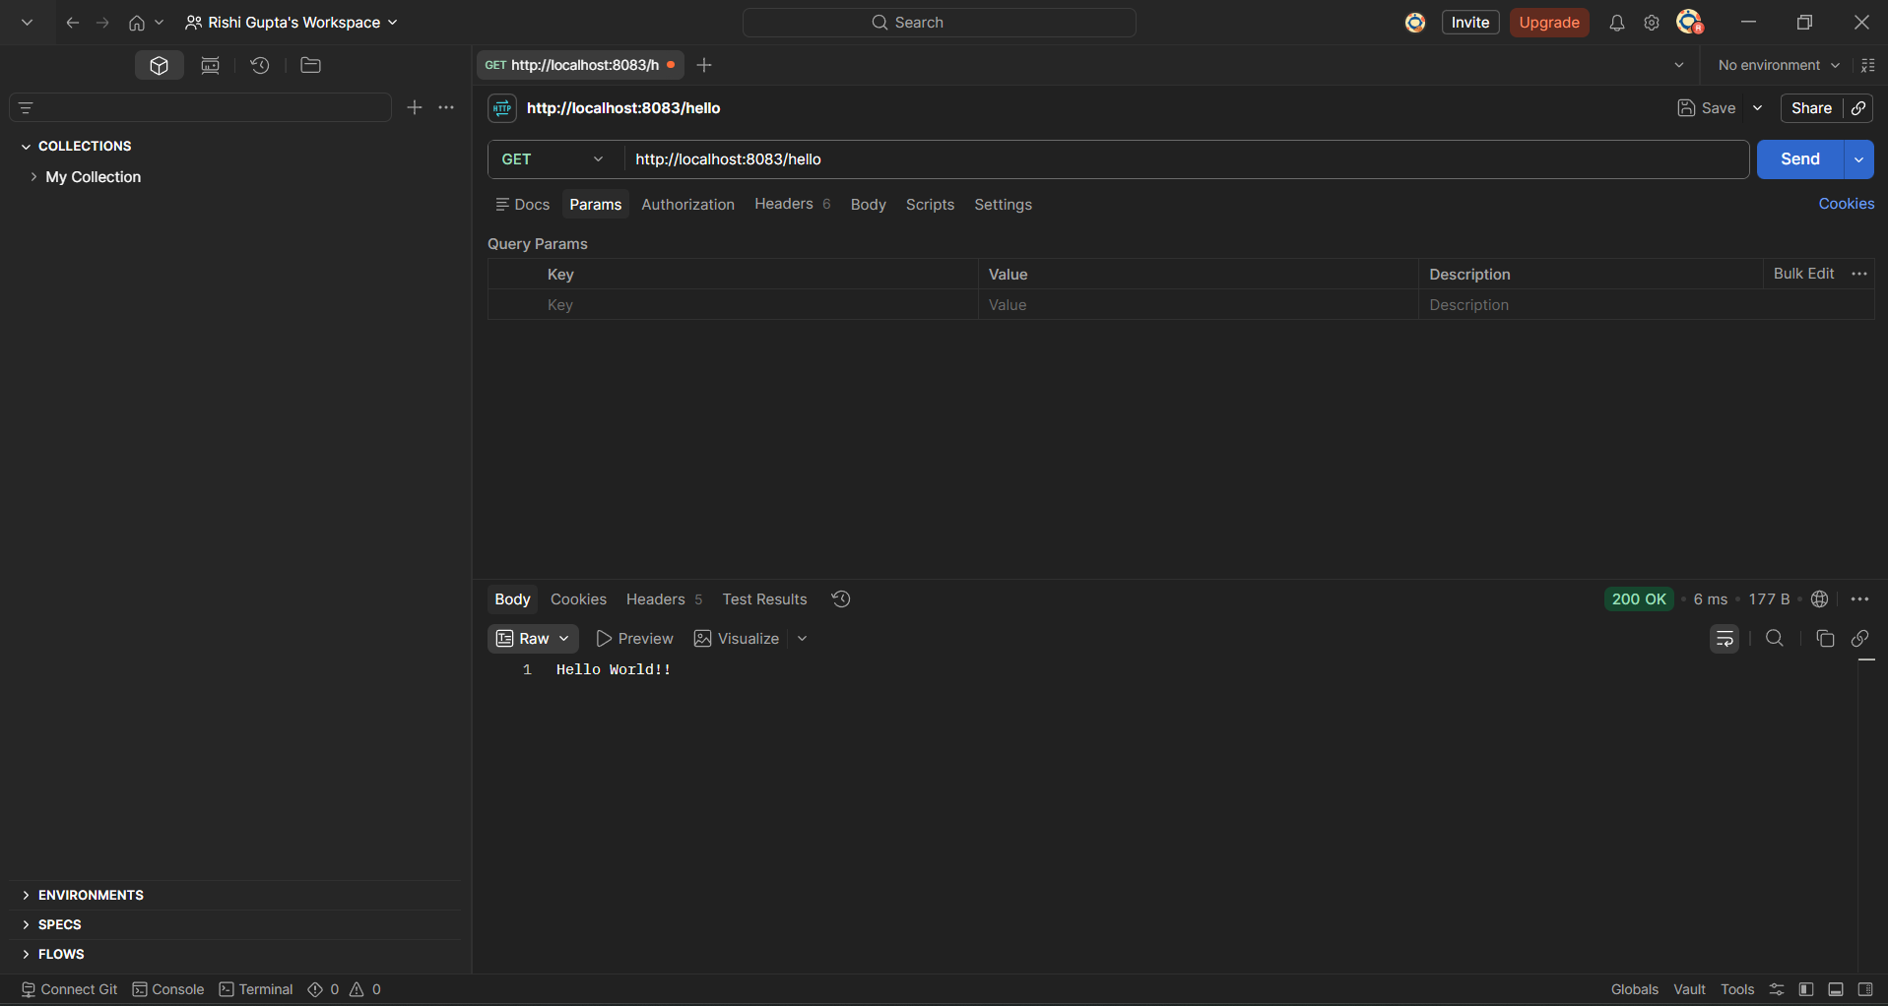
Figure 6: Postman GET request to http://localhost:8083/hello returning status 200 OK with body "Hello World!!".

Testing in Postman - Response Headers
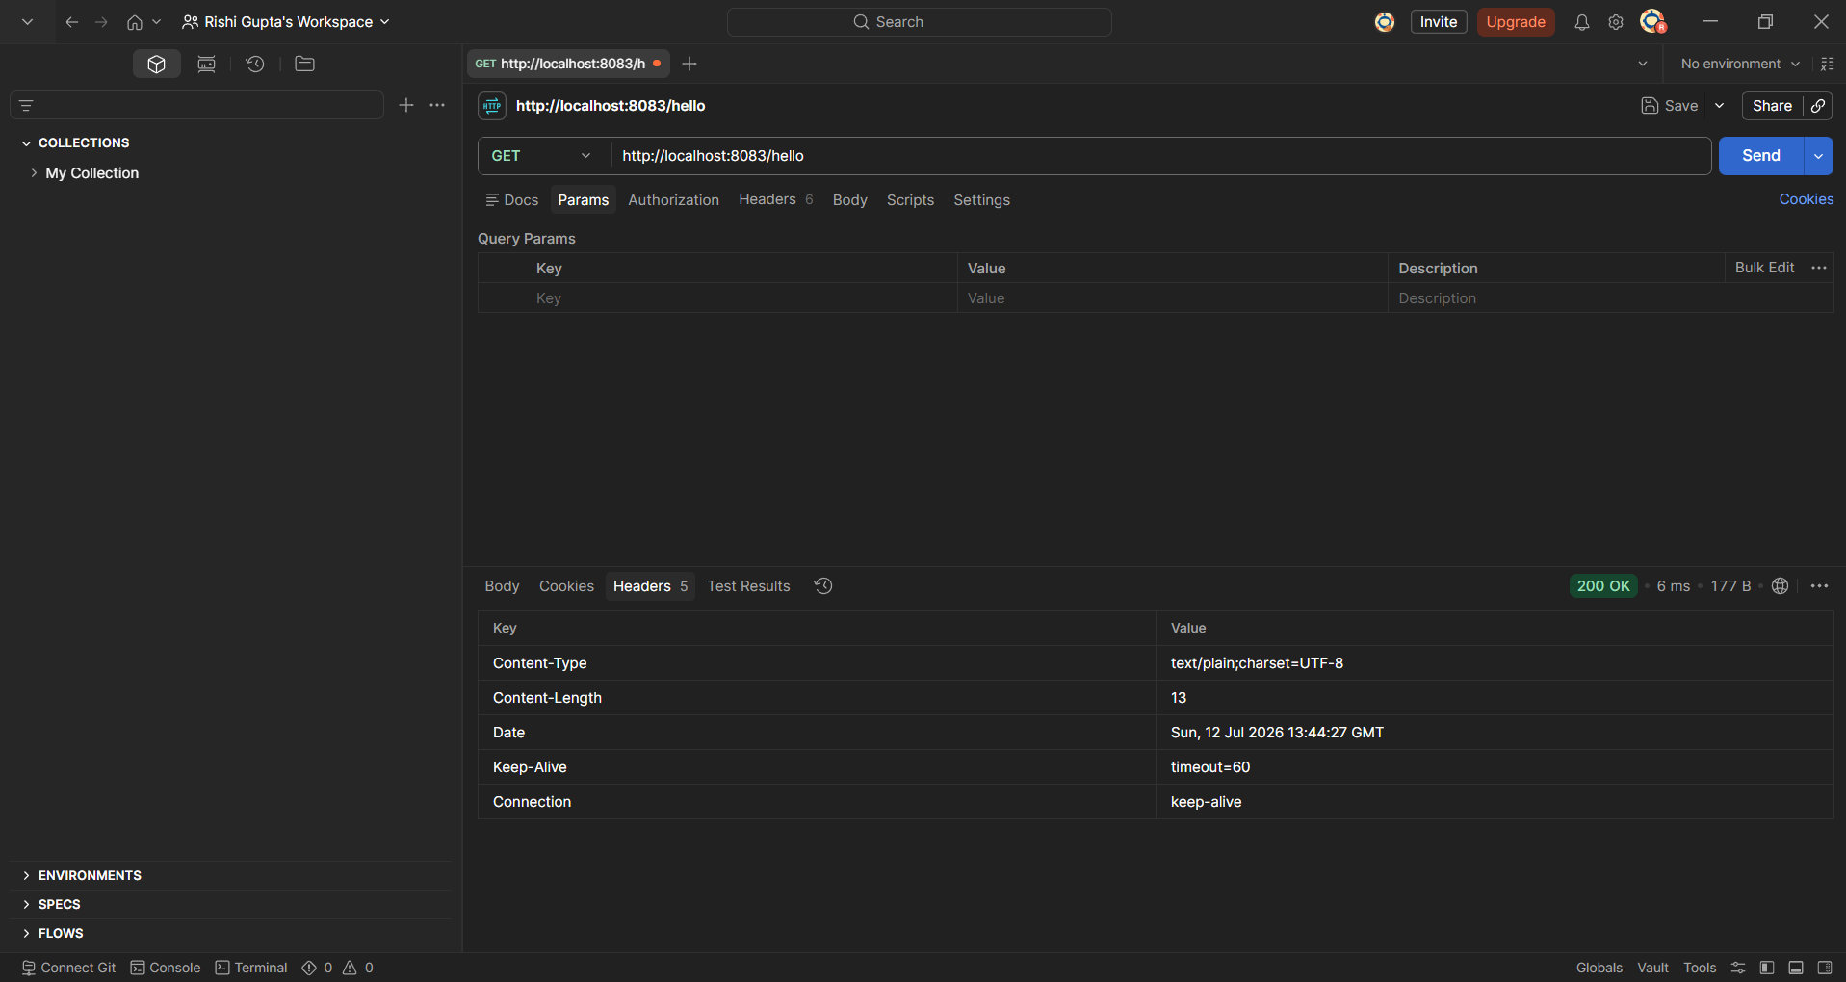
Figure 7: Postman Headers tab showing response headers received from the server.

